FEATURES RECOMMENDATION:
Small points: Adding “Contact us” and “Copyright”
1/ Reliability
To make it more intuitive. If it is possible to add link between how the values for a certain feature of the fund was derived and where the information was obtained from the fact sheet.

Example:
” Yearly running cost: S$1,750/yr (1.75% a year)” (Source: Management fee, 20260615-VINACAPITAL-VDEF_Monthly-Factsheet_May-2026-EN.pdf)

2/ Comparison:
We can consider deeper comparison for example:
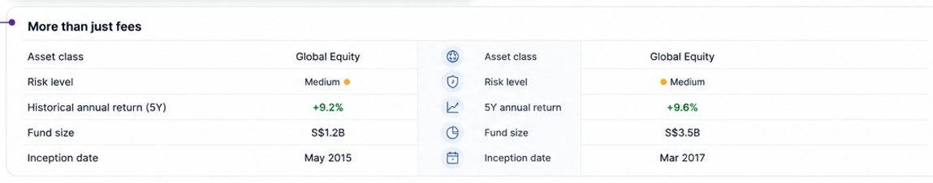
3/ Information on expected returns should be reflected

UI/UX

